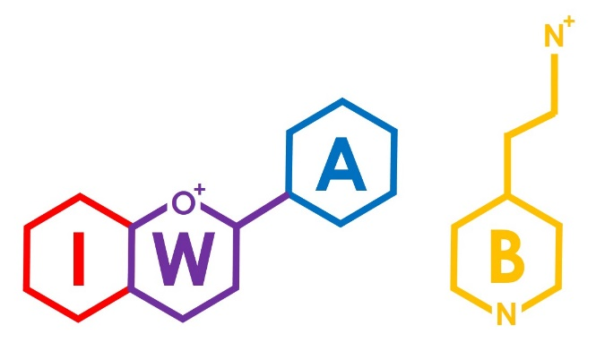
11th International Workshop on Anthocyanins & Betalains, 17-19 September 2024, University of Leeds, UK

The 11th International Workshop on Anthocyanins & Betalains (IWA&B 2024) is hosted by The University of Leeds and held in the United Kingdom for the first time. This conference presents a unique opportunity to meet and discuss with colleagues from all over the world, get updated on the newest developments and insights in the colourful world of anthocyanins and betalains, and will provide unique possibilities to network and discuss collaborations.
The conference is the world’s primary conference on anthocyanins and betalains, and brings together global leaders in the subject area from academia and industry.
An Invitation to Exhibit and Sponsor
About the Conference
The 11th International Workshop on Anthocyanins & Betalains (IWA&B 2024) will be held in at The University of Leeds in the county of Yorkshire. Yorkshire is known as “God’s Own Country” and is the largest county in the United Kingdom, home to leading University cities and miles of unspoilt countryside, including The Yorkshire Three Peaks.
The University of Leeds was established in 1904 and is one of the largest universities in the UK. The University is part of the Russell Group of research-intensive universities and are renowned globally for the quality of our research and teaching, ranked in the top 75 universities in the world. More than 39,800 students are currently studying here at both undergraduate and postgraduate levels.
Anthocyanins are well known for their great diversity of colours, spanning practically the whole visible spectrum, from orange and red through to purple and blue hues. Due to their wide distribution in nature and structural diversity they have hit headlines and are linked to a range of health benefits and diverse functions in plants. Over the years, the scientific community has been focusing on these amazing molecules trying to understand their biosynthesis, properties, bioactivities and biological relevance, and possible applications. Given their relative abundance in the diet and their chemical and biological versatility, they represent a rich source of health promoting properties and only now are we truly beginning to understand how their absorption might relate to bioactivity.
Similarly, novel anthocyanin-enriching techniques are opening new opportunities for several applications in various industry sectors for manufacturing food and non-food products including their potential use as food additives, cosmetics and pharmaceuticals.
Since the year 2000, the International Workshop on Anthocyanins (IWA) has been the major bi-annual focus for cutting edge anthocyanin research dissemination. Following on from the successful introduction of betalains at IWA2019 conference, they are also fully included in IWA&B 2024. Betalains are a class of red and yellow pigments found in specific plants where they replace anthocyanins. The particular shades of red to purple are distinctive and unlike that of anthocyanin pigments. Betalains include reddish to violet betacyanins and yellow to orange betaxanthins.
IWA&B 2024 is an opportunity for academics and industrials to establish contacts with other scientists working with anthocyanins and betalains worldwide.

Sponsorship Packages
We hope that your company can participate to this great event by being a sponsor of the conference. IWA&B 2024 is a unique occasion to increase the visibility of your company, build international network and find new inspiration for your business development. Exhibitors/sponsors logos can be displayed on the website from January 2024. Participants will have access to the website also after the conference, for a limited period of time.

 | Silver | Gold | Platinum | Exhibitor
 | £1500 | £2500 | £5000 | £1000
Logo on conference website and in book of abstracts | ✔ | ✔ | ✔
Logo on the homepage of the conference website |  | ✔ | ✔
Logo on the standby slide in the conference rooms | ✔ | ✔ | ✔
Welcome remarks at opening ceremony (5 mins) |  |  | ✔
Welcome reception sponsor |  |  | ✔
Keynote lecture sponsor  (choice on first come first served basis) |  | ✔ | ✔
Distribution of your flyers and goodies | ✔ | ✔ | ✔
Poster session sponsor |  | ✔ | ✔
4 m² exhibition space for duration (optional) |  |  | ✔ | ✔
Conference delegate registrations (including gala dinner) | 1 | 2 | 3 | 0

Application for sponsorship
We would like to be a sponsor of the 11th International Workshop on Anthocyanins & Betalains (IWA&B 2024).

Package Required (Tick one) |  | Silver |  |  | Gold |  |  |  | Platinum
Contact Name:

Company:

Address:

City: |  |  | Post/Zip Code: |  |  |  |  | Country:
Telephone: |  |  |  |  |  | Email:

Please send this completed form to the Conference Chairman:
Professor Richard Blackburn
Chair, Organizing Committee
Leeds Institute of Textiles and Colour
University of Leeds, LS2 9JT, UK
email: r.s.blackburn@leeds.ac.uk

Conference email: IWA@leeds.ac.uk

We will be in touch regarding invoicing and payment.

