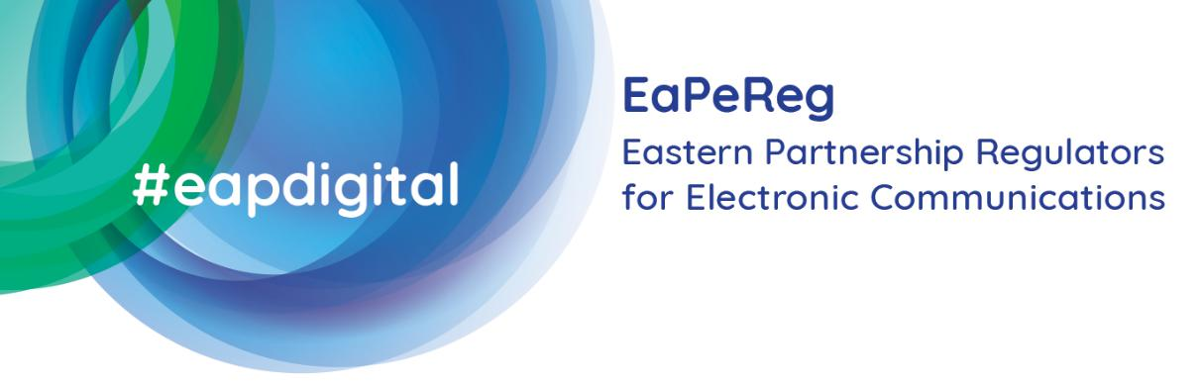
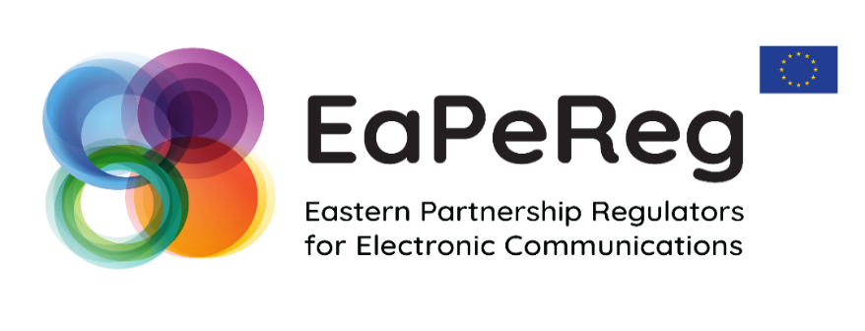
IRB Expert Working Group
Discussing TOGETHER the progress on setting-up the independent NRAs
in the EaP countries
&
further proposals
towards resilient DIGITAL Transformation in EaP

online event
21st of April 2021
AGENDA
Time  (CET) | Topic | Moderator / Speakers
10:30-11.00 | Time for connection – the session will start at 11:00 sharp | Moderator: Chairperson of IRB EWG of EaPeReg, Ms Inga POPOVICI
11:00 – 11:15 | Welcome speech and opening remarks by virtual hosts of the event:  Permanent Representation of Romania  to the European Union  National Authority for Management and Regulation in Communications of Romania (ANCOM) | The Ambassador of the Permanent Representation of Romania  to the European Union, Ms Luminiţa Teodora ODOBESCU  Vice-president of ANCOM, Mr Eduard Lucian LOVIN
11:15 – 12:15 | What is the role of an independent regulator in the challenging digital era?  Presentation of the legislative analysis findings and recommendations in light of relevant  EU regulatory framework requirements and  the draft law that aims at filling the identified gaps | Chairperson of IRB EWG of EaPeReg, Ms Inga POPOVICI  EU4Digital Facility Telecom Rules Stream Leader Mr Andrejs DOMBROVSKIS  Director-General of the Swedish Post and Telecom Authority (PTS), EaPeReg & BEREC Vice-chair in 2021, Mr Dan SJÖBLOM  Representatives of the International Telecommunication Union:  Ms Sofie Maddens, Head of the Regulatory and Market Environment Division, BDT  Representative of the EU MS NRA  Mr. Jeremy Godfrey, Commissioner of the Irish Commission for Communications Regulation
12:15 – 12:30 | Q&A | All participants
12:30 – 13:00 | Proposal for a harmonized approach to measure broadband connectivity:  Methodology for connectivity state-of-play assessment | Chairperson of IRB EWG of EaPeReg, Ms. Inga POPOVICI  World Bank Group, Program Leader in European Union Member States, Europe and Central Asia, Mr Juan NAVAS-SABATER
13:00 – 13:10 | Q&A | All participants
13:10-13:15 | online voting on the presented proposal for a methodology as an instrument for the EaP countries to monitor the connectivity targets | Representatives of the EaP line ministries
13:15– 13:30 | Closing remarks | European Commission:  Mr. Hoa-Binh Adjemian, Head of Sector Economic Development and Digital Eastern Partnership, DG NEAR  Mr. Philippe Gérard, Adviser for Capacity Building & Cooperation with Third Countries, DG CONNECT  EaPeReg Chair in 2021, Mr Alexander Zhyvotovsky, Head of the National Commission for the State Regulation of Communications and Informatization (NCCIR) of Ukraine

