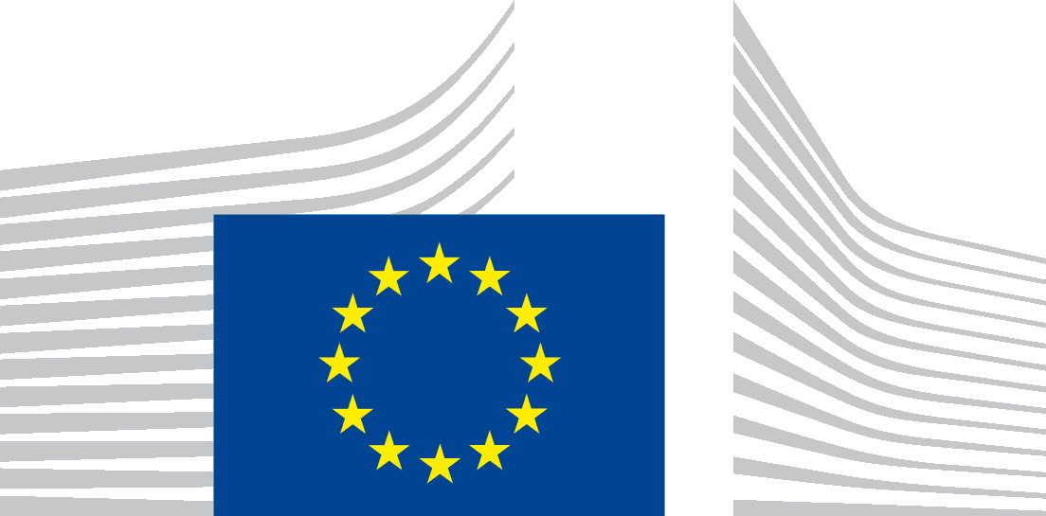 | EUROPEAN COMMISSION

PROTECTION OF YOUR PERSONAL DATA
This specific privacy statement provides information about the processing and the protection of your personal data.

Processing operation: ‘2022 Seminar on Fisheries Science’
Data Controllers: European Commission, Directorate General for Maritime Affairs and Fisheries, Unit C3
Record reference: DPR-EC- 01063 processing of personal data linked to meetings and events

Table of Contents

- Introduction
- Why and how do we process your personal data?
- On what legal ground(s) do we process your personal data?
- Which personal data do we collect and further process?
- How long do we keep your personal data?
- How do we protect and safeguard your personal data?
- Who has access to your personal data and to whom is it disclosed?
- What are your rights and how can you exercise them?
- Contact information
- Where to find more detailed information?

1. Introduction
The European Commission (hereafter ‘the Commission’) is committed to protect your personal data and to respect your privacy. The Commission collects and further processes personal data pursuant to Regulation (EU) 2018/1725 of the European Parliament and of the Council on the protection of natural persons with regard to the processing of personal data by the Union institutions, bodies, offices and agencies and on the free movement of such data.
This privacy statement explains the reason for the processing of your personal data in the context of the 2022 Fisheries Science Seminar. It explains the way we collect, handle and ensure protection of all personal data provided, how that information is used and what rights you have in relation to your personal data. It also specifies the contact details of the responsible Data Controller with whom you may exercise your rights, the Data Protection Officer and the Data Protection Supervisor.
The information in relation to the processing of personal data ‘2022 Seminar on Fisheries Science’ undertaken by the Directorate-General for Maritime Affairs and Fisheries (DG MARE), Unit C3, of the Commission, is presented below.

2. Why and how do we process your personal data?

Purpose of the processing operation: DG MARE, Unit C3 collects and uses your personal data to:
- provide you with information about the 2022 Seminar on Fisheries Science (before, during and after the event);
- process your application for participation in the event;
- allow you to gain access to the Commission premises.
Audio-visual recording of speakers, organisers and participants for the purpose of livestreaming, as well as photographs of speakers and participants will be taken during the physical and virtual activities of the event. The activities of participants attending the event online will be webstreamed.
These visual materials, including screenshots of participants and speakers attending the event online, will be used for communication purposes and be published at the 2022 Seminar on Fisheries Science website and the DG MARE twitter account. The audience or non-speaker participants are not photographed individually or in groups. They may however appear on panoramic photographs of the whole event/audience.
Names of speakers will be published on the event platform, the event’s website, and may be published on the general European Commission websites and social media.
Participants that do not wish to be part of the above photos, videos, webstreaming and publishing activities have the possibility to object to processing by sending an e-mail to MARE-C3@ec.europa.eu prior to the event. A registered participant can attend/participate online but she/he is not obliged to show her/his image or she/he may ask questions in written via the chat facility and not intervene orally.
Your personal data will not be used for any automated decision-making including profiling.
3. On what legal ground(s) do we process your personal data?

The processing operations on personal data linked to the organisation, management, follow-up and promotion of the event (including photographs) are necessary for the management and functioning of the Commission, as mandated by the Treaties. Those provisions are in particular, Article 11 of the Treaty on European Union and Article 15 of the Treaty on the Functioning of the European Union.

Consequently, those processing operations are lawful under Article 5(1)(a) of Regulation (EU) 2018/1725 (processing is necessary for the performance of a task carried out in the public interest or in the exercise of official authority vested in the Union institution or body).

Your consent is required for the following actions during the event (if applicable):

- the processing of your personal data relating to your dietary and/or access requirements;
- the sharing of the participants list containing your name and affiliation with other participants for the purpose of networking activities or future collaboration;
- web-streaming of participants
- the publication of the photos for promotion and public relation efforts relating to the event on the event website, the European Commission websites and social media channels
- granting access to the event platform, and for networking purposes for speakers:
- additional information may be collected, such as a biography and photograph for possible promotion before, during and after the Seminar;
- the joining in a virtual event studio, for speakers joining remotely, including processing of personal details and, video and/or audio connection.
- the processing of your personal data for inviting you to future events organised by DG MARE, Unit C3
You can give your consent via a clear affirmative act by ticking the box(es) on the online registration form. If you opt-in, you are giving us your explicit consent under Article 5(1)(d) of Regulation (EU) 2018/1725 to process your personal data for those specific purposes.

Your consent for these purposes can be withdrawn at any time by sending an email to MARE-C3@ec.europa.eu

4. Which personal data do we collect and further process?

The following personal data may be processed in the context of the event:
- contact details (function/title, first name, last name, name of organisation, city, country, e-mail address, telephone number, ID number);
- dietary requests (if any) or specific access requirements;
- photographs and audio-visual material of the event

5. How long do we keep your personal data?

DG MARE, Unit C3 only keeps your personal data for the time necessary to fulfil the purpose of collection or further processing.
For each of the categories of personal data that may be processed, please find below the retention details and the reference to the relevant record of processing:
- Personal data related to the organisation and management of the 2022 Seminar on Fisheries Science (this includes the information given during the registration, before, during or after the event) will be kept for five years after the event.
- Sensitive personal data relating to dietary and/or access requirements will be deleted as soon as they are no longer necessary for the purpose for which they have been collected in the framework of the event, but no later than within 1 month after the end of the Event.
- Personal data shared with DG MARE, Unit C3 for future mailing purposes (e.g., for receiving invitations to similar events) are processed in line with the Record of Processing: DPR-EC-03928 (Management of subscriptions to receive information).

- Personal data shared with the Directorate-General for Human Resources and Security of the Commission for the participants to gain access to Commission buildings is kept for 6 months after the termination of the link between the data subject and the Commission. More information is available in the Record of Processing DPR-EC-00655 (Commission Physical Access Control System (PACS)).
The selected service provider MCI Benelux S.A., for the event management organisation is contractually bound to process personal data on behalf of and in line with the instructions of the data controller, keep confidential any data they process and protect it from unauthorised access, use and retention.
6. How do we protect and safeguard your personal data?

All personal data in electronic format (e-mails, documents, databases, uploaded batches of data, etc.) are stored either on the servers of the European Commission or of its contractor, i.e. the selected service provider MCI Benelux S.A. All processing operations are carried out pursuant to Commission Decision (EU, Euratom) 2017/46 of 10 January 2017 on the security of communication and information systems in the European Commission.

The Commission’s contractor is bound by a specific contractual clause for any processing operations of your personal data on behalf of the Commission, and by the confidentiality obligations deriving from the General Data Protection Regulation (‘GDPR’ - Regulation (EU) 2016/679). The processors have to put in place appropriate technical and organisational measures to ensure the level of security, required by the Commission.

In order to protect your personal data, the Commission has put in place a number of technical and organisational measures. Technical measures include appropriate actions to address online security, risk of data loss, alteration of data or unauthorised access, taking into consideration the risk presented by the processing and the nature of the personal data being processed. Organisational measures include restricting access to the personal data solely to authorised persons with a legitimate need to know for the purposes of this processing operation.

7. Who has access to your personal data and to whom is it disclosed?

Access to your personal data is provided to the Commission staff responsible for carrying out this processing operation and to other authorised Commission staff according to the “need to know” principle. Such staff abide by statutory, and when required, additional confidentiality agreements.

Where necessary, we may also share your information with the contractor MCI Benelux S.A. for the purpose of organising the Seminar. Service provides are hosting personal data in the EU, or have BCRs in place (WebEx, Docusign).
- For registration purposes: Aventri (privacy policy – cookie policy - EU servers)
- Session Q&A and polling tool: Slido (privacy policy - EU servers)
- Video-conferencing software: Cisco WebEx (privacy policy – BCRs and EU Servers)
- For email and chat management: Freshdesk (privacy policy - EU Servers
- Live streaming and temporary Video-on-Demand: Clevercast (privacy policy – EU Servers)
- For event platform: Swapcard (privacy policy – EU Servers)

Cookies

Cookies are short text files stored on a user’s device (such as a computer, tablet or phone) by a website. Cookies are used for the technical functioning of a website (functional cookies) or for gathering statistics (analytical cookies).

The collection of pre-registration data and email campaigns will be managed via the software Aventri. The system uses essential cookies and cookies to improve your website experience and to generate anonymous, aggregate user statistics. Aventri does not do anything with the data apart from storing it for the Contractor (MCI Benelux S.A). Event reminder emails and a post-event follow up email will be sent through Aventri (cookie policy). The only cookies that will be collected during the registration process for this event are:
- PHPSESSID: Retains session state of a user activity (1st Party – Session Cookie)
- Regtoken: To track cookie consent of all essential cookies (1st Party – Session Cookie)
- selectedlanguage: Track chosen Language (1st Party – Expires in 1 day)
- cookieconsent_status: Track cookie consent of essential cookies (1st Party – Expires in 12 months)
Neither of these cookies can read or access other cookies or any data from a user’s hard drive. Further, neither of these cookies alone will personally identify a user; however, a cookie will recognize a user’s individual web browser or device through an IP Address, browser version, operating system and other information.

When you visit the website(s) of our event and when you register, we will keep the browser history of your visit for a maximum of 12 months. This information will then be deleted. The collection, aggregation and anonymising operations are performed in the data centre of the European Commission under adequate security measures.

Cookies are stored by Europa Analytics, the corporate service which measures the effectiveness and efficiency of the European Commission's websites on EUROPA. More information is available in the Record of Processing DPR-EC-00685 (Europa Analytics).

Enabling these cookies is not strictly necessary for the website to work but it will provide you with a better browsing experience. You can delete or block these cookies, but if you do that, some features of the meeting/event website may not work as intended.
The cookie-related information is not used to identify data subjects personally and the pattern data is fully under the Commission’s control. These cookies are not used for any purpose other than those described here.

Should you wish to opt your personal data out of our anonymised, aggregated statistics, you can do so on our cookies page. In particular, you can control and/or delete those cookies as you wish.

Third party IT tools, including Social Media

We use third party IT tools to inform about and promote the 2022 Seminar on Fisheries Science through widely used communication channels, including the social media. For detailed information about the use of social media by the European Commission, see the Record of Processing DPR-EC-00073 (Social Media Use by the European Commission).
You may be able to watch our videos, which may be also uploaded to one of our social media pages (DG MARE facebook page and DG MARE twitter account) and follow links from our website.
In order to protect your privacy, our use of third party IT tools to connect to those services does not set cookies when our website pages are loaded on your computer (or other devices), nor are you immediately redirected to those social media or other websites. Only in the event that you click on a button or “play” on a video to watch it, a cookie of the social media company concerned will be installed on your device. If you do not click on any social media buttons or videos, no cookies will be installed on your device by third parties.
In order to view such third-party content on our websites, a message will alert you that you need to accept those third parties’ specific Terms and Conditions, including their cookie policies, over which the Commission has no control.
We recommend that users carefully read the relevant privacy policies of the social media tools used Twitter, LinkedIn, Instagram and YouTube. These explain each company’s policy of personal data collection and further processing, their use of data, users' rights and the ways in which users can protect their privacy when using those services. In case the event is held online, using a third party IT service, by accepting to participate into the Event you are consenting to the processing of your personal data via the third party tool, according to its privacy policy.
The use of a third party IT tool does not in any way imply that the European Commission endorses them or their privacy policies. In the event that one or more third party IT tools are occasionally unavailable, we accept no responsibility for lack of service due to their downtime.

8. What are your rights and how can you exercise them?

You have specific rights as a ‘data subject’ under Chapter III of Regulation (EU) 2018/1725 and of the GDPR, in particular the right to access your personal data and to rectify them in case your personal data are inaccurate or incomplete. Where applicable, you have the right to erase your personal data, to restrict the processing of your personal data, to object to the processing, and the right to data portability.

You have the right to object to the processing of your personal data, which is lawfully carried out pursuant to Article 5(1)(a) of Regulation (EU) 2018/1725 on grounds relating to your particular situation.

If you have consented to provide your personal data to the data controller for the present processing operation. You can withdraw your consent at any time by writing to MARE-C3@ec.europa.eu . The withdrawal of your consent will not affect the lawfulness of the processing carried out before you have withdrawn the consent.

You can exercise your rights by contacting the Data Controller, or in case of conflict the Data Protection Officer. If necessary, you can also address the responsible Data Protection Supervisor. Their contact information is given under Heading 9 below.

Where you wish to exercise your rights in the context of one or several specific processing operations, please provide their description (i.e. their Record reference(s) as specified under Heading 10 below) in your request.

9. Contact information

- The Data Controller
If you would like to exercise your rights under Regulation (EU) 2018/1725, or if you have comments, questions or concerns, or if you would like to submit a complaint regarding the collection and use of your personal data, please feel free to contact the Data Controller, DG
MARE, Unit C3: MARE-C3@ec.europa.eu

- The Data Protection Officer (DPO) of the Commission
You may contact the Data Protection Officer (DATA-PROTECTION-OFFICER@ec.europa.eu) with regard to issues related to the processing of your personal data under Regulation (EU) 2018/1725.

- The European Data Protection Supervisor (EDPS)

You have the right to have recourse (i.e. you can lodge a complaint) to the European Data Protection Supervisor (edps@edps.europa.eu) if you consider that your rights under Regulation (EU) 2018/1725 have been infringed as a result of the processing of your personal data by the data controller.

10. Where to find more detailed information?

The Commission Data Protection Officer (DPO) publishes the register of all processing operations on personal data by the European Commission, which have been documented and notified to him. You may access the register via the following link: http://ec.europa.eu/dpo-register.
This specific processing operation has been included in the DPO’s public register with the following Record reference: DPR-EC.01063.
More information on processing your personal data with regard to Cookies stored by Europa Analytics is available in the Record of Processing DPR-EC-00685.
For detailed information about the use of social media by the European Commission, see the Record of Processing DPR-EC-00073.

