Template for Short Paper at Dioxin Symposia

Title not to exceed 200 characters – Times Roman, size 12, bold, centered - Do not use all capital letters

First_name Last_name¹, First_name(2nd author) Last_name(2nd author)², xxx

¹ Affiliation 1st author, street address, city with ZIP, country
² Affiliation 2nd author, street address, city with ZIP, country

Formatting:
Short papers shall be written on A4 size paper with borders of 2 cm; using single spaced or 12 pt paragraphs, justified or left adjusted (paragraph format “normal”)
Title of the paper: Centered, font size 12 pt, bold, capitalize nouns and possessives but not full words. The title should be as brief as possible, not contain abbreviations (if not well established) nor trade names. Maximum of 80/200 characters. Avoid words like “global”, “full”. “first” or other exaggerations
Insert an empty line before authors.
Authors: list all authors by either full first names or initials followed by dot and last name, separate authors by comma and number them in sequence of appearance if they have different affiliations. Corresponding or presenting author should be marked with an asterisk
Insert an empty line before Affiliations.
Affiliations of all authors shall be provided with full address details including country name. Number where necessary in sequence of authors.

Sections: The following section should be part of the short paper
Headings of sections: Numbered, font size 11 pt, face = bold
Tables and Figures: Use consecutive numbering, font size= 10 pt. All text and numbers of tables use font size 10 pt, no italics. Use frames as appropriate.
Italics should be used for Latin names only

Sections (font 11 pt, bold) shall be numbered and be contained as follows:
Insert an empty line before each section.

1 Introduction
Provide a brief description of context of the work presented in this paper, what have others done, why are you undertaking this work. Close by stating the hypothesis to be tested and described in this paper. Include relevant references.

2 Materials and Methods
Describe what you have done in this work: List all chemicals, equipment or materials (do not use proprietary names) used in this study and present in the same sequence as results will be shown in the next section. Where possible, refer to established methods or procedures. Do not include comments, results or discussion in this section.

3 Results
Present your data or findings, which should be essential for the discussion section. Typically, this section does not have references since is restricted to your results in this study. Include tables and figures with self-explanatory headings (not have the same message or data contained in both, figure and table).

Table 1: Table heading above the table (do not use italics). Amounts in ng/kg
Sample | PCB 28 | PCB 52 | PCB 101 | PCB 138 | PCB 153 | PCB 180
Number 1 | 10 | 11 | 13 | 15 | 20 | 16
Number 2
Number 3

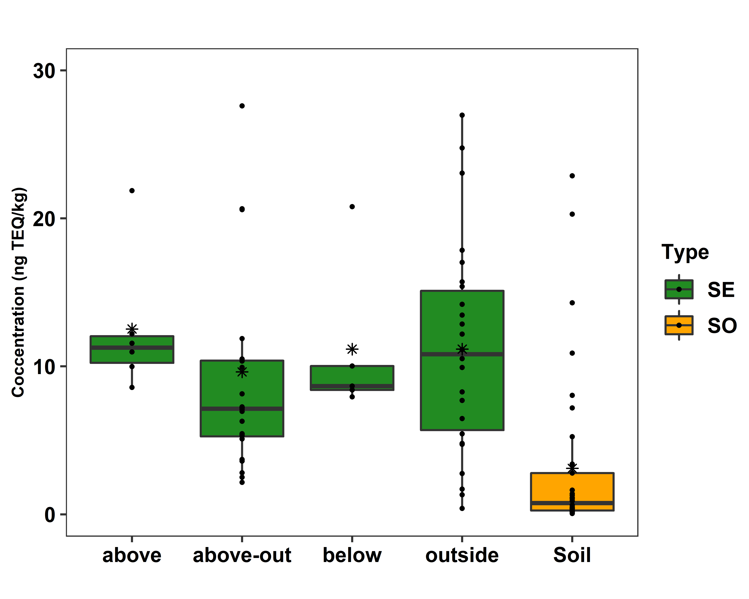
Figure 1: Box plots for sediment and soil samples. Amounts in ng TEQ/kg.
Figure heading below the figure (do not use italics).

4 Discussion
Compare your results with already published work (refer to Introduction), do not reiterate the results. Rather state agreements or disagreements with others.

5 Conclusions
This section would contain proposals how to advance the work further from the present state of knowledge.

6 Acknowledgments
Provide information on funding, acknowledge support by others than the authors, if applicable (not a mandatory section)

7 References
List all references cited in the paper by providing names of all authors (with initials), followed by year of publication, title of the paper (journal article, report, book. Do not italicize the titles of articles), Journals should be abbreviated; for information refer to CAS Source Index (CASSI) (https://cassi.cas.org/search.jsp), include volume and first-last page. Recommended number of references: up to 20 (note: they will not count on limitation of 4 pages).
Note: the abbreviation for Organohalogen Compounds is Organohalogen Compd. (https://cassi.cas.org/publication.jsp?P=eCQtRPJo9AQyz133K_ll3zLPXfcr-WXfBATVNppbwMdlrHf1oa04qgY-ltinzhTEMs9d9yv5Zd8yz133K_ll33DkS-m8AWu9Ms9d9yv5Zd8yz133K_ll38kGZh4Og5za6X5AK-MyDGU)

