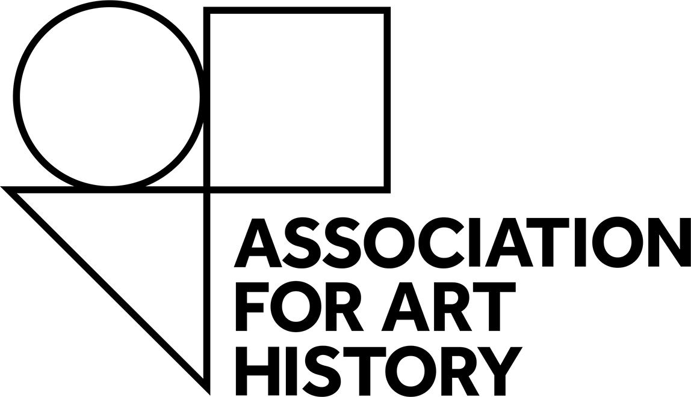

Equalities, Diversity and Inclusion
* Please note that this form should be completed in conjunction with an application to receive a DECR Bursary to the For Art History Annual Conference. Completion of this form is optional, but we urge you to do so, in the interests of meeting our broader equality, diversity and inclusion objectives.
The Association for Art History aims to create and foster an inclusive environment, in our organisation, in our work and across the subject and sector we represent. We want to identify and address the barriers that we and others face in terms of equalities, diversity and inclusion.
Your answers will be treated in strictest confidence, and all data disclosed will comply with the Data Protection Act 1998. You can find out how we manage and process information and data in the Association for Art History Privacy Policy.
The questions that follow relate to some of the protected characteristics under the Equality Act 2010.
To read more about the Association‘s commitment to inclusion please use this link: https://forarthistory.org.uk/about/our-vision/.
The Association adheres to GDPR and data privacy in accordance with our policy that is detailed online here: https://forarthistory.org.uk/privacy-notice/
What is your gender identity?

Is your gender identity the same as your gender/sex assigned at birth?
Yes/No/Prefer not to say

Age Group: Less than 18 years 18-24 25-34 35-44 45-54 55-64 65-74 75 or older Prefer not to say

How would you describe your ethnic origin? Please supply a self-definition and you should state what you feel best represents you:

Disability (a disability is defined as a physical or mental impairment which has a substantial and long-term adverse effect on a person’s ability to carry out normal day-to-day activities)

Do you consider yourself to have a disability? Yes/No/Prefer not to say

How would you describe your sexual orientation?
Bisexual
Gay/Lesbian
Heterosexual/straight
Pansexual
Asexual
Prefer not to say

Where did you hear about this opportunity?

