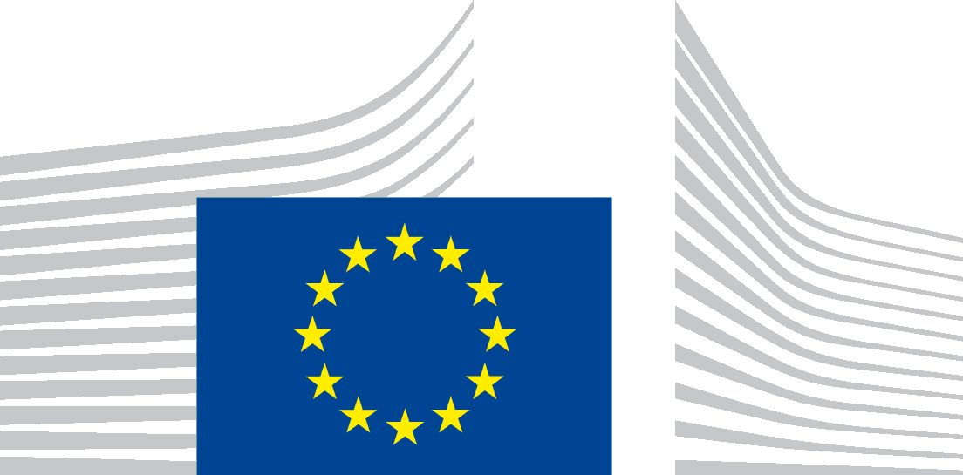 | EUROPEAN RESEARCH EXECUTIVE AGENCY  REA.C – Future Society  C.2 – Secure Society

Data Protection Notice

PROJECTS TO POLICY SEMINAR (PPS) co-organised by DG HOME F.2and REA C.2
Time and place: 14.6-15.6.2023 Hotel Renaissance, Brussels.

In accordance with the Regulation (EU) 2018/1725 on the protection of natural persons with regard to the processing of personal data by the Union institutions, bodies, offices and agencies and on the free movement of such data (‘the Regulation’), the Directorate General for Migration and Home Affairs (DG HOME) and European Research Executive Agency (‘the Agency’ or ‘REA’) collect your personal information only to the extent necessary to fulfil a precise purpose related to our tasks. DG HOME has contracted the physical organisation of the event to MCI Benelux SA (the Contractor) which will process your personal data for organisational, logistical and communication purposes.

Why do we collect your personal data?
We shall collect and process your personal data which is necessary for the organisational aspects of the policy feedback event PPS. It is a two-day policy-focused event that is organised jointly by DG HOME and REA, with a number of projects from the 2020 H2020 Security call. Your personal data is collected to invite you to the event, have access to the online registration tool and follow-up on actions and for other preparatory purposes. The purpose of the event is to share scientific and policy-related information among participants, exchange good practice, enhance cooperation, and allow interactive discussions.

Who is responsible for this process?
The controllers are REA and DG HOME. For organisational reasons, the role of the data controller has been entrusted to REA C.2 Acting Head of Unit Ms Valeria Bricola and to DG HOME F.2 Head of Unit Mr Nicolas Bessot.
The data controllers may be contacted via the functional mailbox: REA-C2-EVENTS @ec.europa.eu and HOME-CERIS@ec.europa.eu.

What is the legal basis to collect your data?
The processing is necessary for the performance of a task carried out in the public interest or in the exercise of official authority vested in the Union institution or body (Article 5(1)(a) of Regulation) and, for compliance with a legal obligation to which the controller is subject (Article 5(1)(b) of Regulation), as established by the following EU legal acts:
Council Regulation (EC) No 58/2003 of 19 December 2002 laying down the statute for executive agencies to be entrusted with certain tasks in the management of Community programmes, OJ L 11, 16.1.2003;
REA Establishment act: Commission Implementing Decision (EU) 2021/173 of 12 February 2021 establishing the European Climate, Infrastructure and Environment Executive Agency, the European Health and Digital Executive Agency, the European Research Executive Agency, the European Innovation Council and SMEs Executive Agency, the European Research Council Executive Agency, and the European Education and Culture Executive Agency and repealing Implementing Decisions 2013/801/EU, 2013/771/EU, 2013/778/EU, 2013/779/EU, 2013/776/EU and 2013/770/EU;
REA Delegation Act: Commission Decision C(2021)952 of 12 February 2021 delegating powers to the European Research Executive Agency with a view to the performance of tasks linked to the implementation of Union programmes in the field of Research and Innovation, Research of the Fund for Coal and Steel and Information Provision and Promotion Measures concerning Agricultural Products comprising, in particular, implementation of appropriations entered in the general budget of the Union..
Article 5(1)(d) of the Regulation based on the data subject explicit consent for the following:
- Communication purposes: video recording and images of the speakers and the participants, taken and published on REA/DG HOME IntraComm, REA EUROPA website and on REA’s/DG HOME’s Twitter accounts;
Networking purposes: sharing participants’ personal data in digital format with other registered participants of the event. You have the right to withdraw your consent at any time, without affecting the lawfulness of the processing before the withdrawal of your consent.

Which personal data are collected?
The personal data processed in the framework of the PPS event organisation are:
- For the event organisation (mandatory data): your contact details, i.e. title, first name, last name, position/function, and email address;

Upon your consent:
- For communication purposes: images and video recordings of the speakers and participants.
- For networking purposes your contact details, i.e. title, first name, last name, position/function, and email address.

Who will have access to your personal data?

Who will have access to the data within the Agency?
REA C.2 and DG HOME F2 staff are in charge of the organisation of the event. Access is always on a need to know basis.

Who will have access to the data outside the Agency?
Authorised European Commission staff for policy purposes and the Contractor for the purpose of the event organisation;

Other participants of the event with your consent for the purpose of networking and communication.

In addition, data may be disclosed to public authorities, which may receive personal data in the framework of a particular inquiry in accordance with Union or Member State law and shall not be regarded as recipient (such as the European Court of Justice, OLAF, EPPO, etc.). The processing of those data by those public authorities shall comply with the applicable data protection rules according to the purpose of the processing. Personal data will not be transferred to third countries (outside EU/EEA) or international organisations.
Personal data is collected via the registration platform Aventri. Furthermore, emails and chat will be sent via Freshdesk and input may be collected during the event via Slido. Where relevant, limited data will also be shared with selected hotel and travel agency to complete your booking. Neither the operating DG, nor data processor MCI Benelux S.A., share personal data with third parties for direct marketing.

How long do we keep your personal data?
We are keeping your personal data for a period as indicated below:
- Contact details processed for the purpose of the organisation and management of the meeting will be deleted after the last action of the PPS event follow-up, for a period up to 12 months.
- After the last action of this processing operation/after end of the event these data will be anonymised and kept for statistical purposes.
- Personal data resulting from the video and audio footage activity: video recordings and images from the event will be kept for up to two years after the event.
- Personal data regarding the dietary needs / mobility restrictions of participants will be deleted at the latest one month after the event.

How do we protect and safeguard your personal data?
All personal data in electronic format (e-mails, documents, databases, uploaded batches of data, etc.) are stored on the servers of the European Commission (or of its contractors, if contractors are engaged to assist the controller in the organisation and management of a specific meeting or event). All processing operations are carried out pursuant to Commission Decision (EU, Euratom) 2017/46 of 10 January 2017 on the security of communication and information systems in the European Commission.
In order to protect your personal data, the Commission has put in place a number of technical and organisational measures. Technical measures include appropriate actions to address online security, risk of data loss, alteration of data or unauthorised access, taking into consideration the risk presented by the processing and the nature of the personal data being processed. Organisational measures include restricting access to the personal data solely to authorised persons with a legitimate need to know for the purposes of this processing operation.
If the controller uses (a) service provider(s) (processor(s)) to assist the controller in the organisation of a specific meeting or event, this will be indicated in the privacy statement of that meeting or event and the following paragraph will be provided:
The Commission’s processors (contractors) are bound by a specific contractual clause for any processing operations of your personal data on behalf of the Commission. The processors have to put in place appropriate technical and organisational measures to ensure the level of security, required by the Commission.

What are your rights?
You may have access to your personal data and may exercise your right of information / access / rectification / erasure / restriction / data portability / objection / withdrawal of consent by contacting the data controller at: REA-C2-EVENTS @ec.europa.eu and/or HOME-CERIS@ec.europa.eu.
Any request from a data subject to exercise a right will be dealt within one month from receipt of the request. This period may be extended pursuant to Article 14(3) of Regulation (EU) 2018/1725.
Your right to information, access, rectification, erasure, restriction or objection to processing, communication of a personal data breach or due to confidentiality of electronic communications may be restricted only under certain specific conditions as set out in the applicable Restriction Decision in accordance with Article 25 of Regulation (EU) 2018/1725.

Contact Information
In case you have any questions about the collection/processing of your personal data, you may contact the data controller who is responsible for this processing activity by using the following email address: REA-C2-EVENTS @ec.europa.eu and/or HOME-CERIS@ec.europa.eu.
Further to the above, the following instances can be addressed to:
REA Data Protection Officer (DPO): REA-DATA-PROTECTION-OFFICER@ec.europa.eu or Commission Data Protection Officer: DATA-PROTECTION-OFFICER@ec.europa.eu
In case of conflict, complaints can be addressed to the European Data Protection Supervisor: EDPS@edps.europa.eu.

Regulation (EU) 2018/1725 of the European Parliament and of the Council of 23 October 2018 on the protection of natural persons with regard to the processing of personal data by the Union institutions, bodies, offices and agencies and on the free movement of such data, and repealing Regulation (EC) No 45/2001 and Decision No 1247/2002/EC (OJ L 295 of 21.11.2018, p.39).
For REA’s privacy policy and social media use, please consult: https://rea.ec.europa.eu/rea-privacy-policy-and-social-media-use_en

