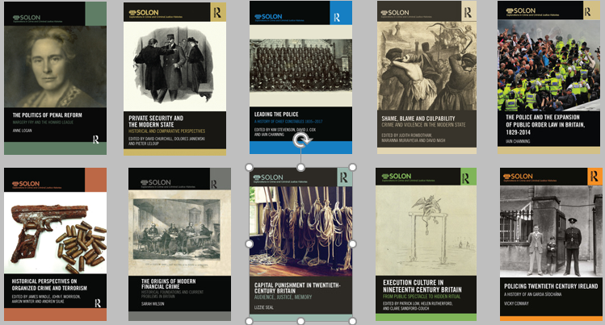
RoutledgeSOLON Explorations in the Histories of Crime and Criminal Justice
This highly successful series, launched in 2011 and publishing 17 books to date, is a collaboration between Routledge and the SOLON consortium of partnership universities (including Plymouth, Oxford Brookes, Wolverhampton).
Its aim is to present cutting edge interdisciplinary research into crime and criminal justice history, through monographs and thematic collected editions which reflect on key issues and dilemmas in criminology and socio-legal studies by locating them within a historical dimension. The series emphasizes inspiring historical and historiographical methodological approaches to contextualise and understand current priorities and problems and aims to highlight the best, most innovative interdisciplinary work from both new and established scholars in the field, through focusing on the enduring historical resonances to current core criminological and socio-legal issues.
In addition to the published title images above forthcoming completed manuscripts approved by the Editorial Board and recommended for publication 2021/2022 comprise three monographs and two edited volumes: Rachel Dixon Infanticide: Expert Evidence and Testimony in Child Murder Cases 1688-1955; Eleanor Bland, Policing Suspicion in England and Wales; Michele Pifferi, The Limits of Criminological Positivism; Jo Turner et al, Policing Women; Sinead Ring, Kate Gleeson and Kim Stevenson Legal Responses to Historical Child Sexual Abuse: Critical and Comparative Perspectives
The Editorial Board welcomes proposals from relevant disciplines and is happy to discuss potential ideas before submission. The General Editors are: Kim Stevenson
University of Plymouth Kim.Stevenson@Plymouth.ac.uk; Judith Rowbotham
University of Plymouth, Judith.Rowbotham@plymouth.ac.uk; David Nash
Oxford Brookes University, dsnash@brookes.ac.uk; David J. Cox
University of Wolverhampton, D.Cox@wlv.ac.uk; Zoe Alker
University of Liverpool, Z.Alker@Liverpool.ac.uk
To submit a proposal please visit https://www.routledge.com/our-customers/authors/how-to-publish-with-us

