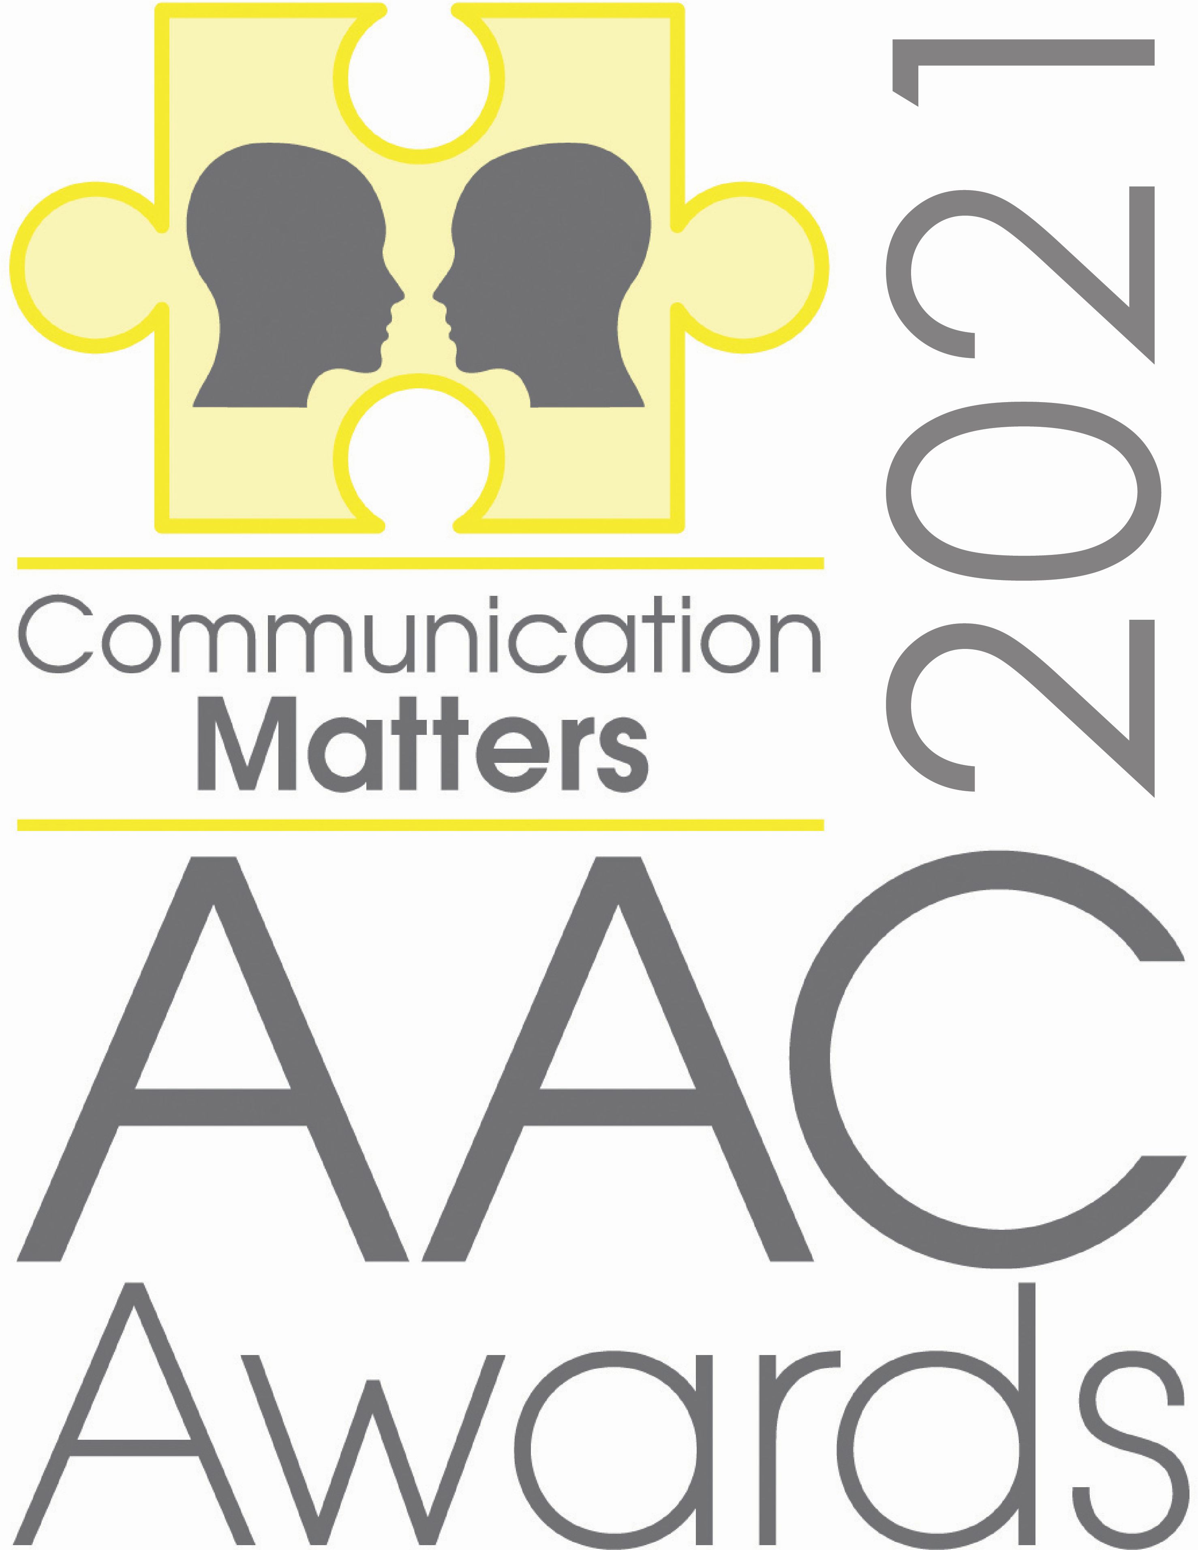 |  | Your name:  Relation to nominee / job title:  Organisation:  Contact email address:  Contact phone number:  Are you likely to be attending the virtual awards on 17th September 2021? YES / NO  Name of nominee:  Please include a photo (if you have gained their permission to do so)  Organisation / position held:  Is the nominee likely to be attending the awards on 17th September 2021? YES / NO  Who should we contact if the person wins?  Please attach any evidence including a statement of between 200 – 250 words on why this person / organisation should be nominated. The most successful nominations could include video or photo evidence of the nominee’s work / skills or an online link. Any additional brief testimonials from a range of people working with this person / team are also encouraged.  Only the information you have provided will be used by the panel when reaching their decision, so the more information you provide the better.  Please email this form and any attachments to: admin@communicationmatters.org.uk by 30th July.  Communication Matters (ISAAC UK) - The UK charity for AAC www.communicationmatters.org.uk  Registered Office: ISAAC (UK), Garbutt & Elliott, Triune Court, Monks Cross Drive, York YO32 9GZ  Company Registered in England & Wales No. 01965474  Registered Charity No. 327500

PLEASE TICK THE AWARD THAT YOU ARE NOMINATING FOR:

THE Jamie Munro award

THE Alan martin award

THE RISING STAR AWARD

GrOUP OF THE YEAR AWARD

OUTSTANDING COMMUNITY INCLUSION (LOCKDOWN LEGEND) AWARD

nOMINATION FORM

Terms & Conditions:

- Closing date for nominations: Friday 30th July.
- Winners will be notified by: Friday 20th August.
- The winner will be announced at the virtual Awards ceremony on 17th September 2021.
- If you would like to attend the Awards, please register for the virtual Communication Matters International AAC Conference by: 3rd September.

Privacy Notice:
- Under the Data Protection Act (2018), we require you to confirm that you have permission to share the personal data required for making a submission to the AAC Awards. This includes gaining permission from the nominee to share their details. The data will be accessed by Communication Matters personnel and the judging panel. This form and any evidence sent with it will be disposed of immediately following the awards, in line with our Privacy Policy. Please tick this box to show you agree

